Social Sharing Kit for ISAGCA Members
“Quick Start Guide: An Overview of ISA/IEC 62443 Standards” Work Product
---
The ISA Global Cybersecurity Alliance’s Advocacy and Adoption work group has overseen the development of a brand new, user-friendly overview of the ISA/IEC 62443 series of standards. These are the world’s only consensus-based standards for automation cybersecurity.
As a member of ISAGCA, your company may wish to share this product of our efforts on social media. We’ve created a few sample posts across various platforms that you’re welcome to share if you’re interested in doing so. Please feel free to change the wording of these posts to fit your branding, or simply copy and paste. Don’t forget to tag the International Society of Automation in your posts and/or use the #ISAGCA hashtag!

1. Guide to Cybersecurity Standards
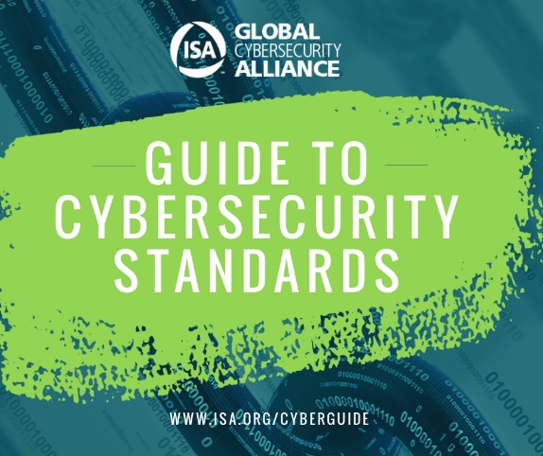
LinkedIn and Facebook: As a member of the International Society of Automation’s Global Cybersecurity Alliance, [Company Name] is committed to a building a resilient, cybersecure world, and standardization is one key aspect. Download a quick start guide to the world’s only consensus-based automation cybersecurity standards at www.isa.org/cyberguide. #ISAGCA
(continued next page)

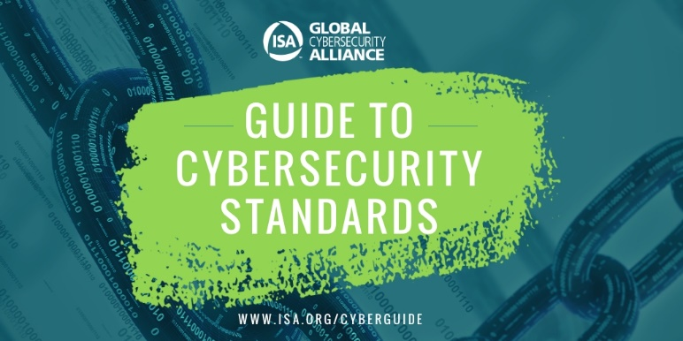
Twitter: We believe in the importance of automation cybersecurity standards. That’s why we’re members of @ISA_Interchange’s Global Cybersecurity Alliance. Download a free guide to the world’s only consensus-based automation cybersecurity standards at www.isa.org/cyberguide. #ISAGCA
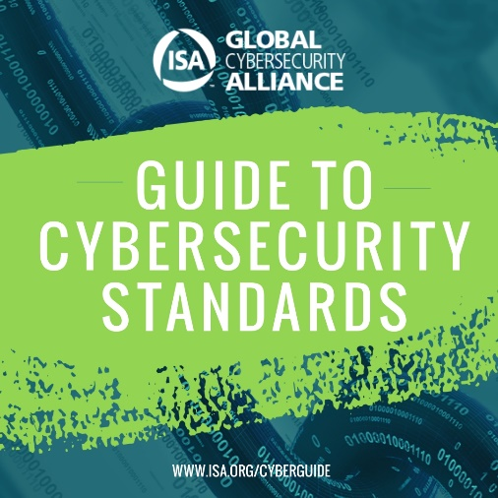
Instagram: We’re members of the International Society of Automation’s Global Cybersecurity Alliance, which just released a guide to the world’s only consensus-based automation cybersecurity standards. Download a free copy of your own at www.isa.org/cyberguide. #ISAGCA

